VOYAGE VISTA: Illuminating insights from uber expeditionary analysis

# PROJECT REPORT

INTRODUCTION:

In an era defined by unprecedented technological advancements, the transportation industry has witnessed a transformative paradigm shift, with Uber at the forefront of this evolution. This project report delves into a comprehensive expeditionary analysis of Uber, aiming to explore the intricate landscape of the ride-hailing giant, its global presence, market positioning, operational strategies, and the implications of its actions on the future of mobility.

OBJECTIVE:

1. To understand the historical evolution of Uber and its impact on the transportation industry.

2.To examine the global market presence of Uber and its competitive positioning.

3.To analyze the business model, technological innovations, and sustainability efforts of Uber.

4.To assess the regulatory and legal challenges faced by the company.

5.To project future trends and challenges in the mobility sector and the role Uber plays in shaping them.

METHODOLOGY:

This expeditionary analysis project will employ a combination of qualitative and quantitative research methods. Primary data will be gathered through surveys and interviews with Uber stakeholders, while secondary data will be sourced from academic literature, industry reports, and media sources. A thorough examination of financial statements and market data will complement the analysis

SCOPE:

This report will focus on Uber's operations and strategies on a global scale. It will include a comparative analysis of Uber's competition and will address emerging trends in the ride-hailing and mobility industries. Additionally, it will discuss the challenges and opportunities presented by emerging technologies like autonomous vehicles.

STRUCTURE OF THE REPORT:

1. Historical Evolution of Uber

2.Global Market Presence and Competitive Landscape

3.Business Model and Technological Innovations

4.Regulatory and Legal Challenges

5.Future Trends and Implications

SIGNIFICANCE:

This expeditionary analysis report on Uber is not only a comprehensive study of a pioneering disruptor in the transportation industry but also a valuable resource for policymakers, industry professionals, and individuals interested in the future of mobility. Uber's journey has implications that reach far beyond ride-sharing, and this report will shed light on the company's role in shaping the landscape of transportation.

PROBLEM DEFINITION AND DESIGN THINKING:

1.Empathy Map:

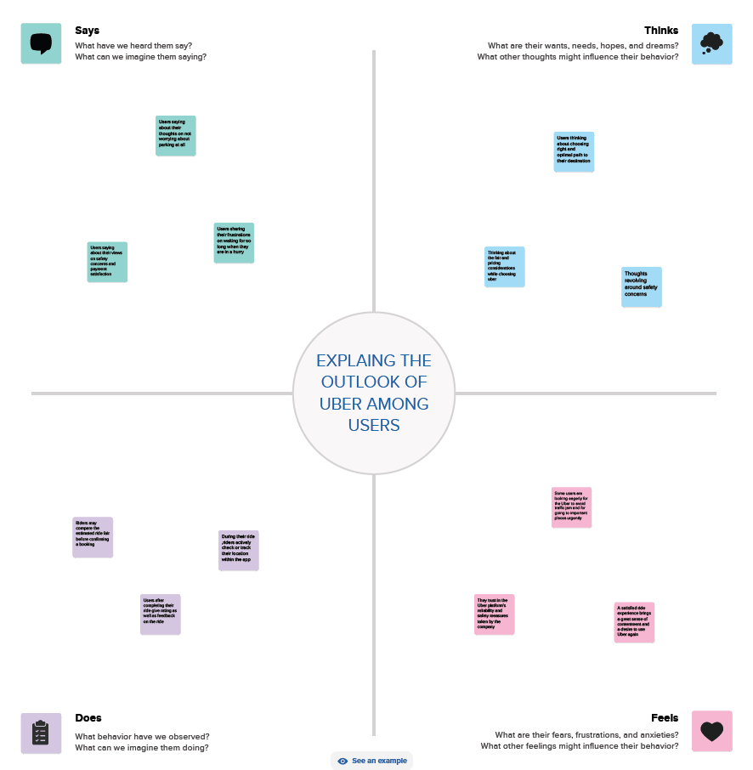

2.Ideation and Brainstorming Map

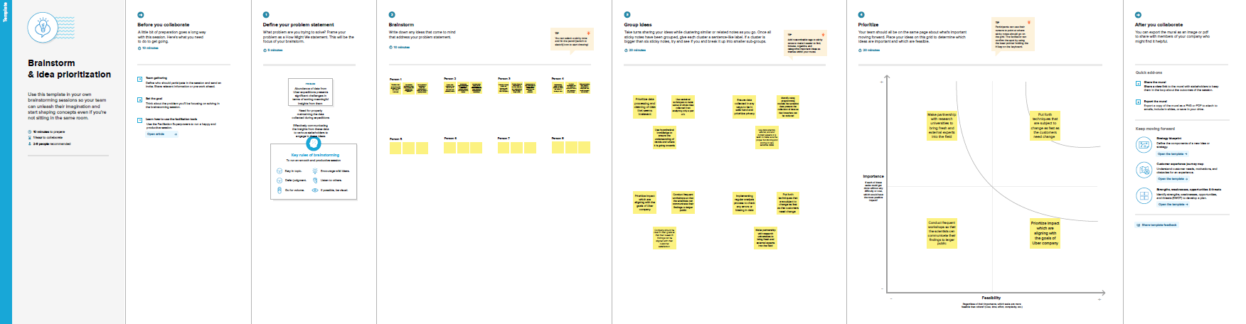

## RESULT:

## 

1.Dashboard (a):

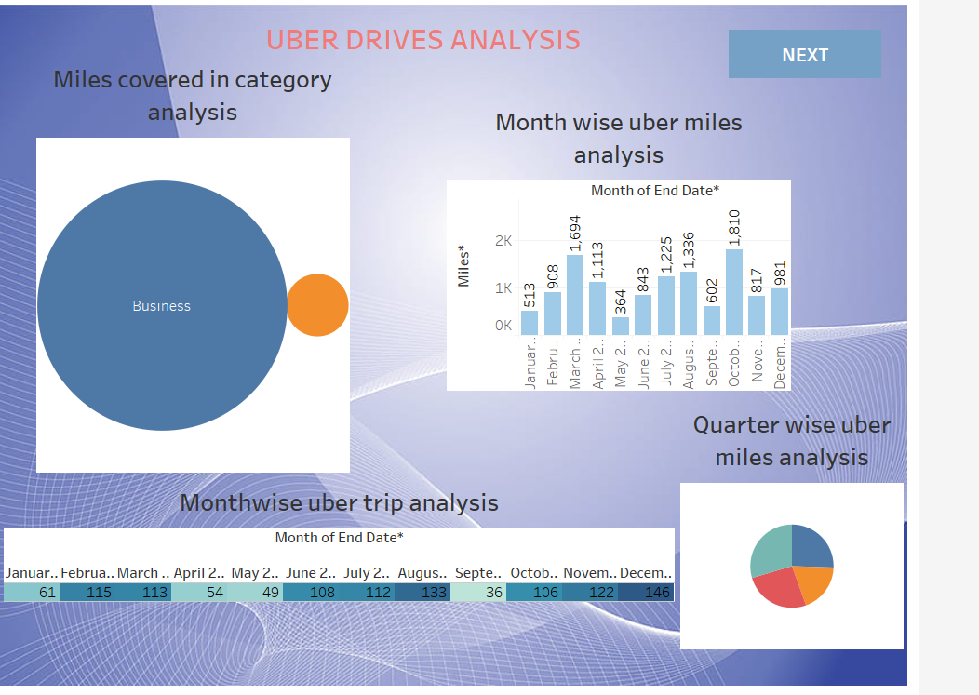

2.Dashboard (b):

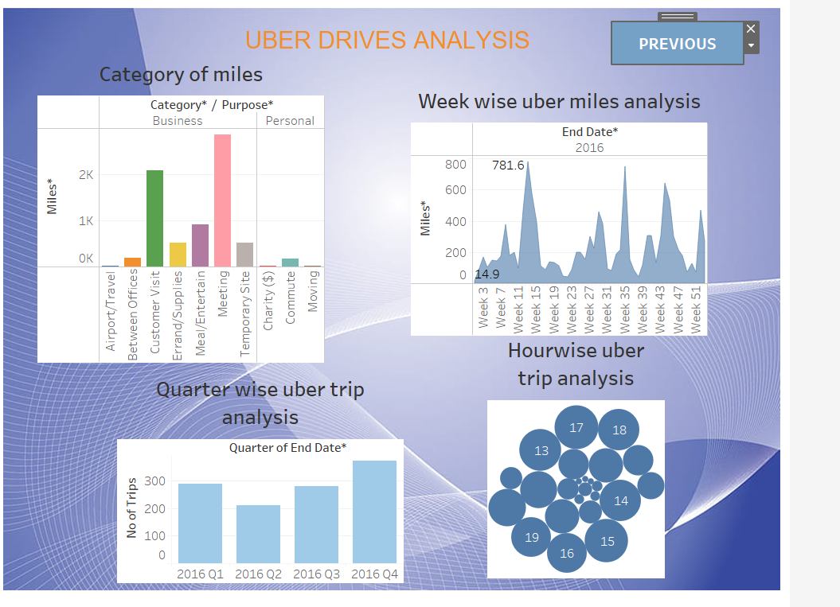

3.Story (a):

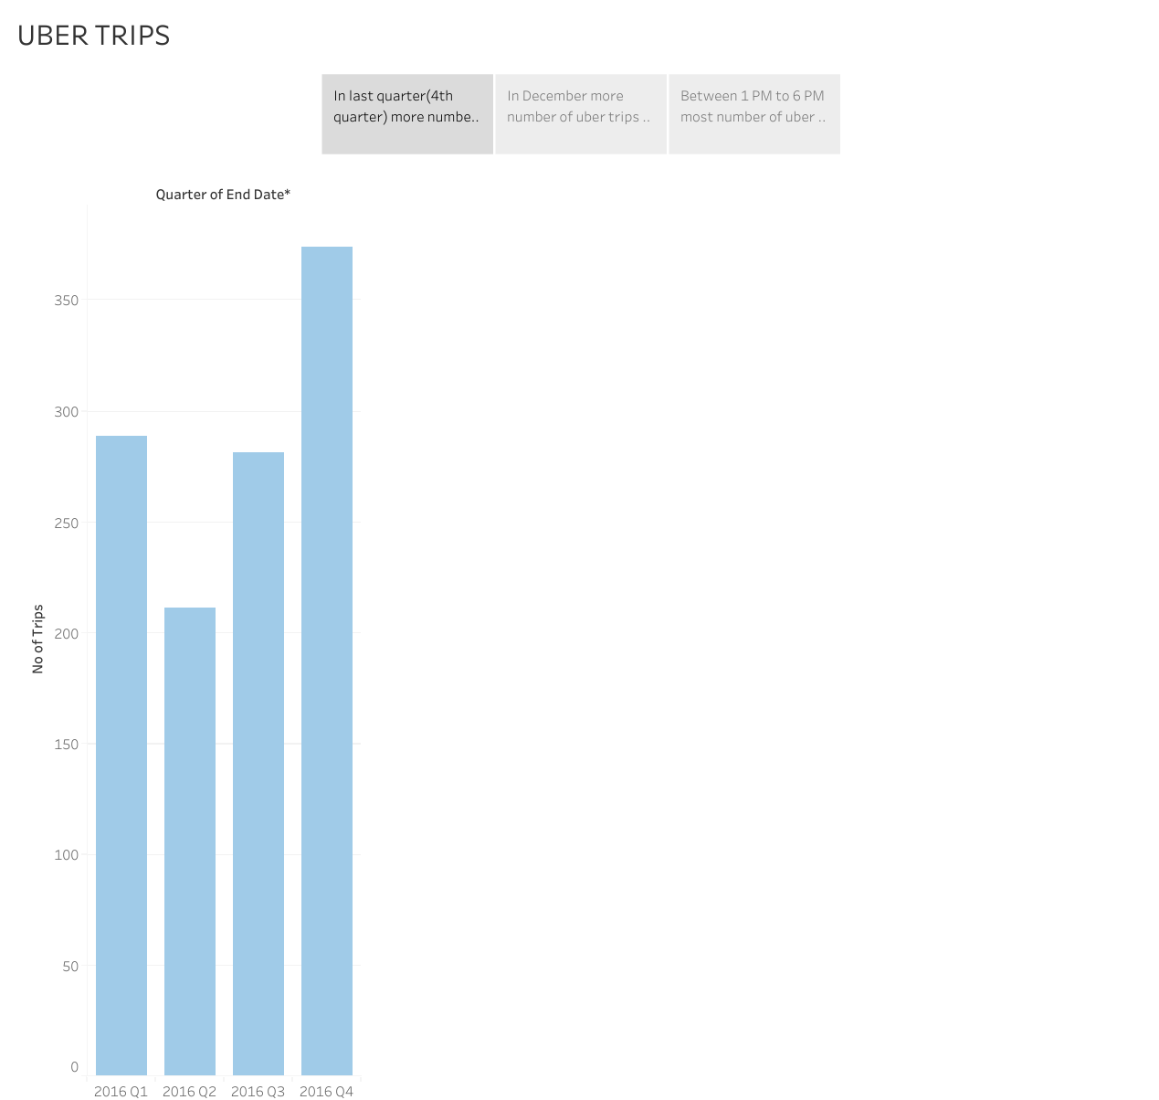

4.Story (b):

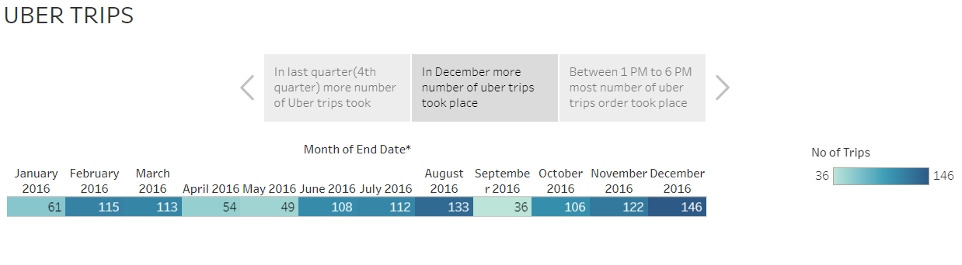

5.Story (c):

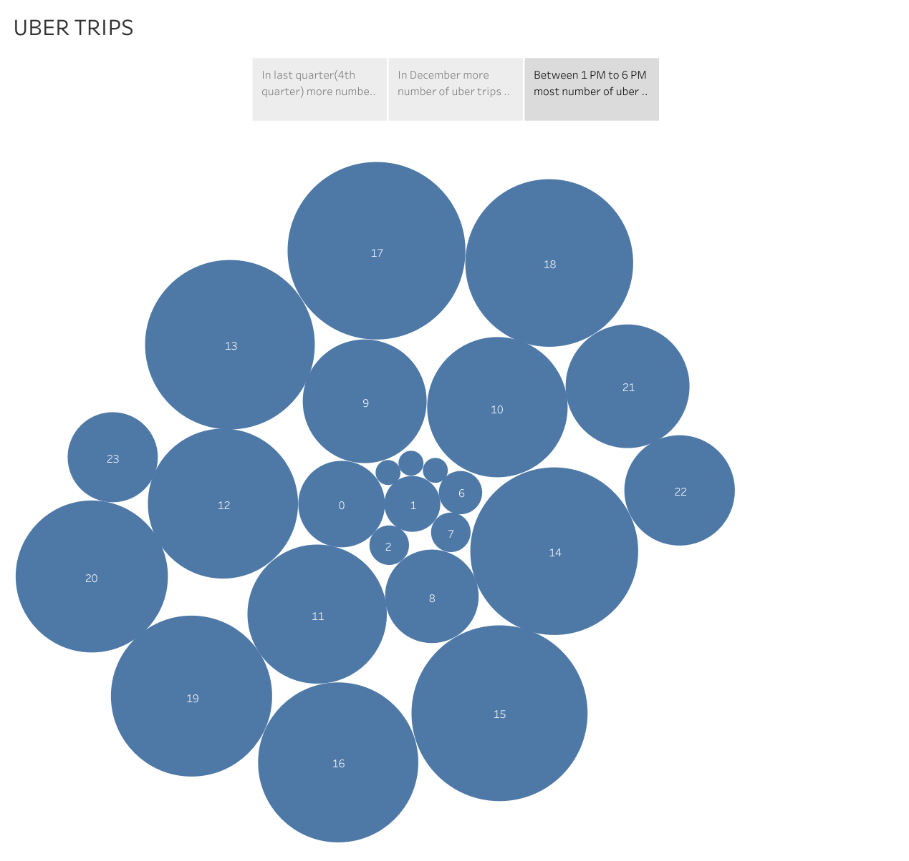

## ADVANTAGES:

1.Comprehensive Understanding of Uber:

The project provides a deep insight into Uber's historical evolution, global market presence, business model, technological innovations, and regulatory challenges. This knowledge can be invaluable for stakeholders in the ride-hailing industry and related sectors.

2.Strategic Insights:

By analyzing Uber's strategies and competitive positioning, the project can offer strategic insights for businesses and policymakers in the transportation sector.

3.Innovation Exploration:

The examination of Uber's technological innovations can inspire further innovation in the mobility industry and related fields.

4.Regulatory and Legal Perspective:

The project's assessment of regulatory and legal challenges faced by Uber can serve as a reference for policymakers and legal professionals dealing with the gig economy and transportation regulations.

5.Future Mobility Vision:

The introduction of the "Voyage Vista" concept presents a forward-looking perspective on the future of mobility. It can guide discussions and decision-making related to urban planning, transportation infrastructure, and emerging technologies.

## DISADVANTAGES:

1. Complexity:

The integration of historical analysis and future vision can make the project complex and challenging to navigate for some readers or stakeholders.

2.Speculative Nature:

The "Voyage Vista" concept involves forward-looking projections, which inherently carry a level of uncertainty. The speculative nature of future-oriented concepts can be a disadvantage in terms of practical implementation.

3.Resource-Intensive:

Conducting a thorough expeditionary analysis and envisioning the future of mobility requires a significant amount of time, effort, and resources.

4.Data Availability:

Access to accurate and up-to-date data for such a comprehensive analysis may be limited in some regions or for certain aspects of the project, potentially leading to data gaps.

5.Regulatory and Legal Complexity:

Analyzing the regulatory and legal challenges faced by Uber can be intricate, and it may require legal expertise that is not always readily available.

## APPLICATIONS:

1.Urban Planning and Development: Urban planners can use the project's findings to better understand the impact of ride-hailing services like Uber on cities and make informed decisions about infrastructure, traffic management, and public transportation.

2.Transportation Policy Development: Policymakers can utilize the insights from the project to craft regulations and policies that address the challenges posed by ride-hailing services while fostering innovation in the transportation sector.

3.Business Strategy and Investment: Companies in the transportation and technology sectors can use the project's analysis of Uber's strategies and competitive positioning to inform their own business strategies and investment decisions.

## CONCLUSION:

1.Uber's Pioneering Role: Uber has played a pioneering role in the ride-hailing industry, disrupting traditional transportation models and reshaping the way people move in urban environments.

2.Global Expansion: Uber's global presence is a testament to its ambition and adaptability. It has successfully expanded into numerous regions, adapting to diverse regulatory and market conditions.

3.Business Model and Technology: Uber's innovative business model, driven by mobile technology, has set new standards for convenience and accessibility in transportation services.

## FUTURE SCOPE:

1.Autonomous Vehicles Integration: As autonomous vehicle technology advances, there is a substantial scope for further research and development into integrating self-driving cars into ride-hailing services, as envisioned in the "Voyage Vista" concept.

2.Environmental Sustainability: Future scopes include enhancing the environmental sustainability of ride-hailing services by expanding electric vehicle fleets, improving energy efficiency, and minimizing the carbon footprint.

3.Data-Driven Insights: The collection of vast amounts of data by ride-hailing companies presents an opportunity for data scientists and analysts to derive valuable insights for optimizing transportation systems and user experiences